Math 1 Name ________________________

**Unit 3-7 Linear Programming Practice** Date________

* *I can write, solve and graph the system of equations/inequalities that best models the real-world problem.*
* *I can solve systems of equations graphically, using elimination and substitution.*
* *I can identify the solution of a system of equations as an intersection point on a graph.*
* *I can graph linear inequality on a coordinate plane, resulting in a boundary line (solid or dashed) and a shaded appropriately.*

Amanda likes to make and sell necklaces and bracelets in her spare time and then sell them to other students. Every week she has 10,000 grams of metal and 20 hours (1200 minutes) to work. It takes 50 g of metal to make a necklace and 200 g of to make a bracelet. It takes Amanda 30 minutes to make each necklace and only 20 minutes to make each bracelet. She makes a profit of $3.50 on each necklace and $2.50 on each bracelet.

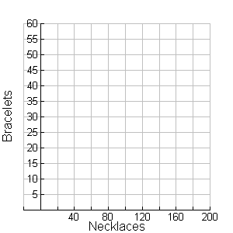Let: *N* = the number of necklaces that Amanda makes per week

*B* = the number of bracelets that Amanda makes per week

1. Using the constraints, write a system of inequalities.
2. Let necklaces (*N*) be the independent variable.

Graph the system of inequalities to the right

and shade the feasible region.

Label your axes and lines.

1. Write an equation for Amanda’s profit

which is to be maximized.

___________________________________

1. What are the 3 vertices of the feasible region Room to find intersection

and what is the profit made at each point?

Vertices Profit

__________________ ____________

__________________ ____________

__________________ ____________

5. Amanda should make _______ necklaces ________ bracelets for a profit of _________.

6. Is the point (20, 10) a viable solution? __________

7. Is the point (80, 40) a viable solution? __________

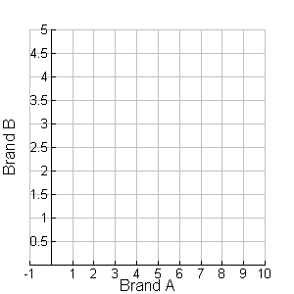A landscaping contractor uses a combination of two brands of fertilizers, A and B, each containing different amounts of phosphates and nitrates. Brand A contains 4 lbs of phosphate, while brand B contains 6 lbs of phosphate. A certain lawn needs at least 24 pounds of phosphates. Brand A contains 2 lbs of nitrate, while brand B contains 5 lbs of nitrate. The same lawn needs at least 16 pounds of nitrates. If *x* is the number of packages of brand A, and *y* is the number of packages of brand B, graph the solution set. Assume that a package of brand A costs $6.99 and a package of brand B costs $17.99. How many packages of each brand would give the lowest cost?

1. Using the constraints, write a system of inequalities.

1. Let Brand A be the independent variable.

Graph the system of inequalities to the right

and shade the feasible region.

Label your axes and lines.

1. Write an equation that will show the cost that we want to minimize.

___________________________________

1. What are the 3 vertices of the feasible region

and what is the cost at each point?

Vertices Cost

__________________ ____________

__________________ ____________

__________________ ____________

5. How much of Brand A should they use? ________________

6. How much of Brand B should they use? ________________

7. What is the lowest cost? ________________

Suppose that a farmer has the option of planting corn and soybeans. At most, he can plant 50 acres. It costs $250 per acre to plant corn and $200 per acre to plant soybeans, and he only has $12000. Graph the possible solutions for the number of acres of corn and soy he could plant. Then assume the profit per acre for corn is $75 and for soy it is $85. Find the amount of acres of corn and soy he should plant in order to maximize the profit.

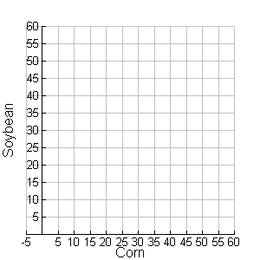

1. Using the constraints, write a system of inequalities.

1. Let Corn be the independent variable.

Graph the system of inequalities to the right

and shade the feasible region.

Label your axes and lines.

1. Write an equation for the farmer’s profit

which is to be maximized.

___________________________________

1. What are the 3 vertices of the feasible region

and what is the profit made at each point?

Vertices Profit

__________________ ____________

__________________ ____________

__________________ ____________

5. How many acres of corn should be planted? ________________

6. How many acres of soybean should be planted? ________________

7. What is the farmer’s profit? ________________

A pet food company wants to mix two kinds of pet food. Kitty Kibbles provides .3 units of iron per ounce and .9 units of calcium per ounce. Puppy Chunks provides .4 units of iron and .5 units of calcium per ounce. The mixture is to have at least 12 units of iron and 29.7 units of calcium. If Kitty Kibbles costs 8 cents per ounce to produce and Puppy Chunks costs 6 cents per ounce to produce, how many ounces of each food should be used in the mixture to meet these requirements while keeping costs to a minimum? What is the minimum cost?

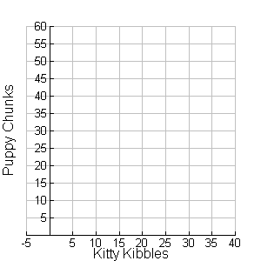

1. Using the constraints, write a system of inequalities.

1. Let Kitty Kibbles be the independent variable.

Graph the system of inequalities to the right

and shade the feasible region.

Label your axes and lines.

1. Write an equation for the cost of making the mixture that you want to minimize.

___________________________________

1. What are the 3 vertices of the feasible region

and what is the cost at each point?

Vertices Cost

__________________ ____________

__________________ ____________

__________________ ____________

5. How much Kitty Kibbles should be used? ________________

6. How much Puppy Chunks should be used? ________________

7. What is the minimum cost? ________________

A furniture manufacturer makes upholstered chairs and sofas. On the average it takes carpenters 7 hours to build a chair and 4 hours to build a sofa. There are enough carpenters for no more than 133 worker-hours per day. Upholsterers average 2 hours per chair and 6 hours per sofa. There are enough upholsterers for no more than 72 worker-hours per day. The profit per chair is $80 and the profit per sofa is $70. How many chairs and sofas should be made per day to maximize the profit?

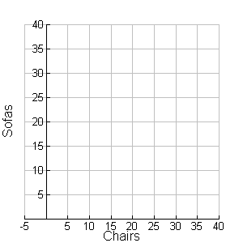

1. Using the constraints, write a system of inequalities.

1. Let Chairs be the independent variable.

Graph the system of inequalities to the right

and shade the feasible region.

Label your axes and lines.

1. Write an equation for the manufacturer’s profit

which is to be maximized.

___________________________________

1. What are the 3 vertices of the feasible region

and what is the profit made at each point?

Vertices Profit

__________________ ____________

__________________ ____________

__________________ ____________

5. How many chairs should be made? ________________

6. How many sofas should be made? ________________

7. What is the manufacturer’s profit? ________________